e.Query Quick Start Guide

Create a Report
- Click the e.Query Design Management icon in the upper left corner
- Click the New button in the lower right corner
- Select a view in the dropdown labeled “Field Options” 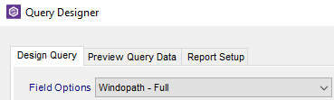
- Double-click any data point(s) on the left to add as FIELD on the report (FIELDS are information that will display on the report). As items are selected, they will appear on the right.
- Use the arrow keys to determine the order you want the information to appear on the report. 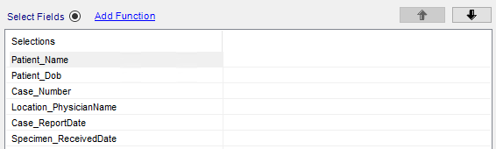
- Click the Select Filters radio button
- Double-click data point(s) to use as filters. Every report needs at least one filter (so the report will not display every patient in the database). 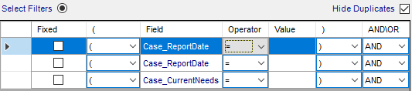
- Adjust the Operator and Value as needed. In the example below, these filters are looking for (1) case was reported greater than or equal to (on or before) 8 days ago, (2) case was reported less than or equal to (on or before) one day ago, and (3) case current needs status is complete. 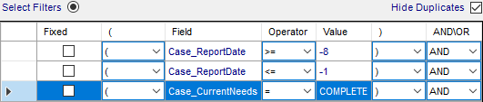
- Click the Execute Preview link to ensure you are getting the data you are expecting 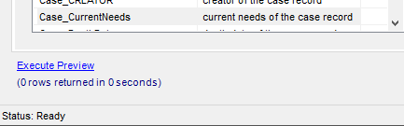
- Click the Report Setup tab in the upper left corner of the Query Designer Window
- Add a Name for the report
- Add/edit any additional options here, including report descriptions, paper orientation, header/footer information, margins, etc
- Click Create Report button 