e.Query Quick Start Guide
Sorting and Grouping Data

Sorting Data
Once a report is created, you can sort the data to appear in the order you want. Sorting will simply re-order the existing data in whichever way you choose.
- From the e.Query Designer, click in the empty gray space to see the e.Query Reports options panel
- Find the Data – Post Execution section, and click in the Sort Clause field
- Click the ellipses button to open the Edit Sort Clause window 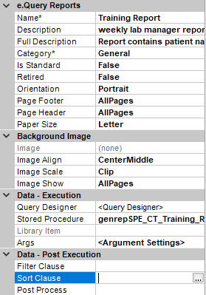
- The left will display all data currently selected on your report. Double-click any data points you want to sort by. For example, if you want to sort all data alphabetically by patient name, see example A below. If you want to sort by Case Report Date, and then sort secondarily by Case Number, see example B below.
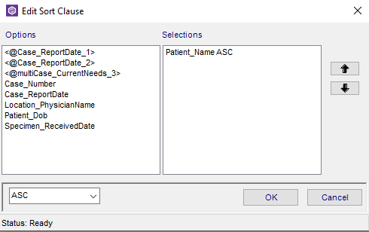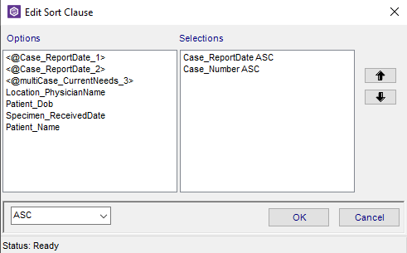
- Use the arrow buttons to indicate the order you want the information to be sorted
- Use the ASC or DESC dropdown to determine if it will be sorted ascending (smallest to largest or alphabetically) or descending (largest to smallest, or reverse alphabetical order).
- Click OK

Grouping Data
Data on your report can also be grouped. Unlike sorting, which simply re-orders the data, grouping will separate data according to how a group is set up. Sorting will still apply within groups. In order words, if you group by Submitter, but sort by Report Date and Case Number, each time you have a new Submitter listed, the data will be sorted by Report Date, and then Case number. To create a group:
- Go to the Commands menu, and sect Add Group 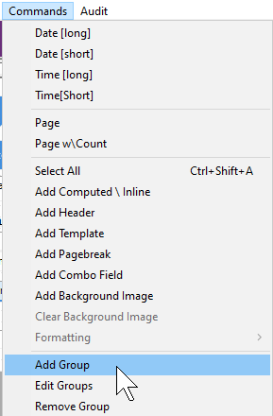
- A Group By window will appear. Select the data point you want to group the data by.
- Select ASC or DESC to determine if you want the information to appear in ascending or descending order
- Select appropriate Keep Together option as desired
- Click OK
In the example below, the report was grouped by submitter (in this view, it is labeled as Location_PhysicianName)
BEFORE GROUP:
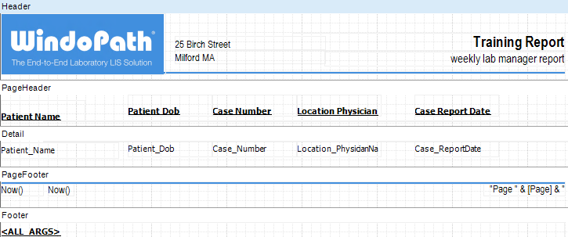

AFTER GROUP:
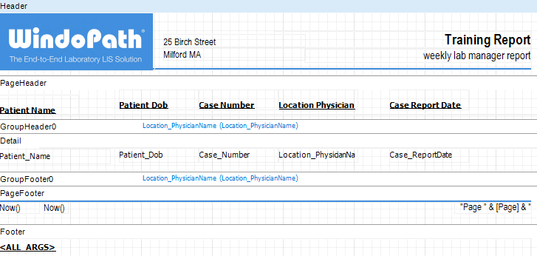
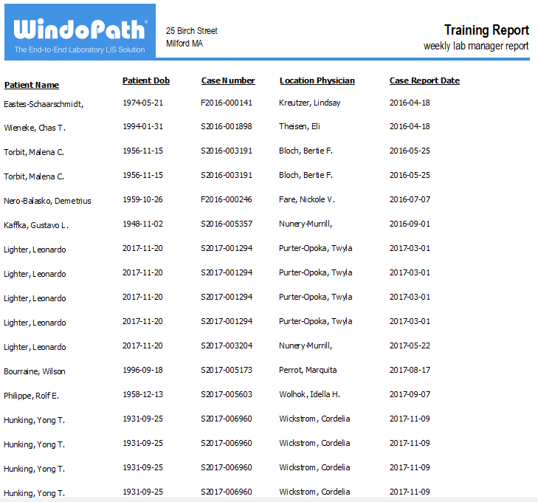
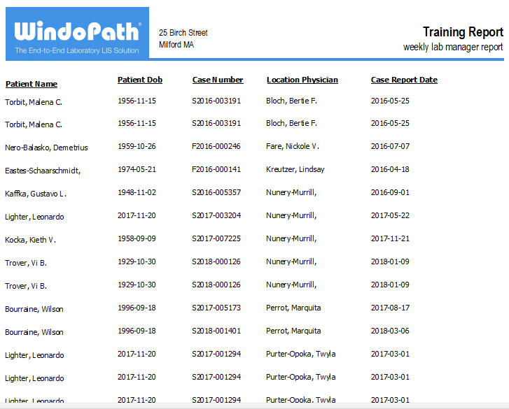

Use the Group Header and Group Footer to place data that will only appear once per group. In the example below, the submitter data field (labeled Location_PhysicianName) was moved into the Group Header. That way, instead of appearing once per line of data, it will appear once per group of data.
BEFORE:
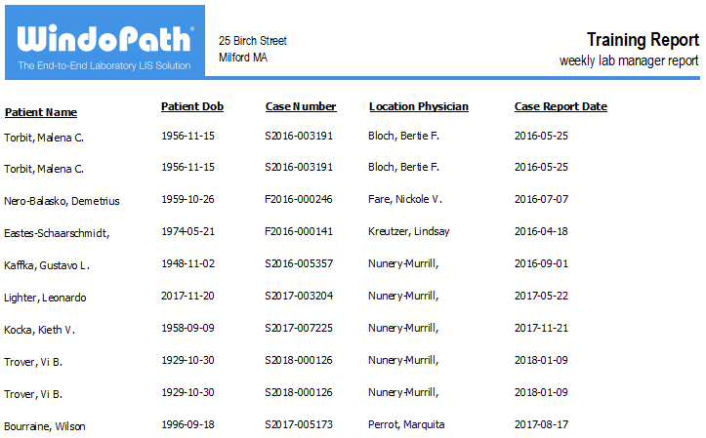

AFTER:
