e.Query Quick Start Guide
Calculating Time Between Two Dates (Date Differentials)

To calculate the amount of time between two dates, use the Date Differential feature.

- From the Commands menu, select Add Computed/Inline
- In the Function Categories dropdown menu, select Date
- In the Function dropdown, select DateDiff 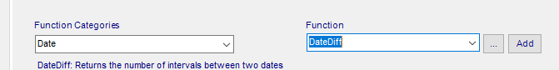
- Click the ellipses button
- Select the interval you want to see for the amount of time between the two dates (how many years, days, hours, etc between the two dates)
- Select the starting date in the dropdown menu
- Select the second/end date in the dropdown menu
- Click OK 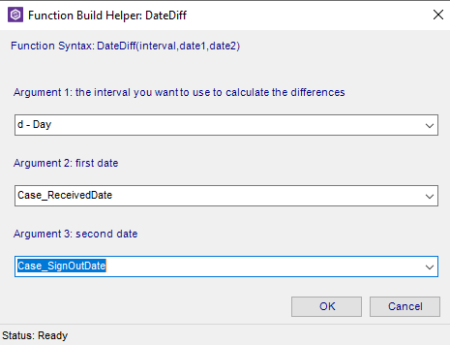
- Note the SQL statement is pulled together based on your selections
- Click OK 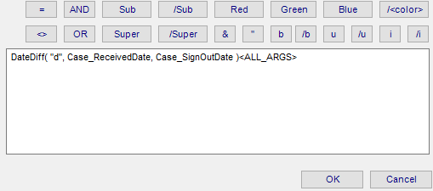
- The data point of DateDiff will appear in your workspace. Move it to where you want it to display on the report
- Add a header or label as desired by using the Add Field button in the lower left corner

