e.Query Quick Start Guide
Totals & Counts

e.Query allows users to count and sum fields. In order to use the sum function, your data fields must contain a number. If you are looking for a total number of cases, use the count function. The count function will add up the number of instances in a data field (in this case, the number of cases). Trying to sum the cases numbers won’t work, as it would be trying to add non-numeric values. For example, you cannot add S2021-0001 + P2021-0003, but you can count S2021-0001 as one case, and P2021-0003 as the second case, etc).

To count:
- Go to the Commands menu, and select Add Computed/Inline
- Under the Common Functions dropdown, select Count
- Under the Count dropdown on the right, select the field you want to count (in the example below, it is Case_Number, which will could the number of cases).
- Click the Add button to the right 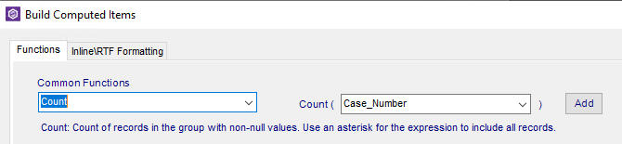
- Note the SQL statement that was populated in the box at the bottom. There should not be a need to change it
- Click OK 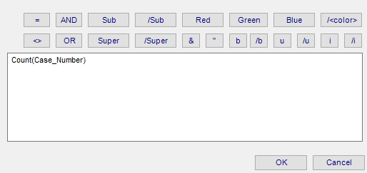
- The Count will be added as a data point. In the example below, I moved it to the Group Footer, so the count of the cases will appear in the footer of each group 